**Name of the College: NIIT R.G.P.G College Meerut **

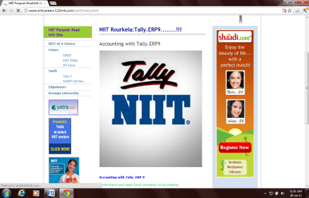 Student Name:________________________________Reg no:________________________

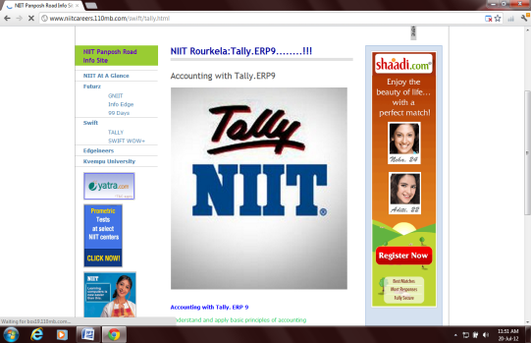 Class:______________Date:_________________Time:30 Min Max Marks: 100 Marks **Set-4**

**QUALIFYING EXAM OF TALLY**

|  |  |  |  |  |  |  |  |
| --- | --- | --- | --- | --- | --- | --- | --- |
| SN | QUESTION_STATEMENT | ANS_A | ANS_B | ANS_C | ANS_D | ANS_E | Ans |
| 1 | The shortcut key used for Online Creation | Alt + A | Alt + C | Alt + D | Alt + B |  | b |
| 2 | We can Split Company Data for | 3 Months | 4 Months | 6 Months | all of the above |  | d |
| 3 | Loss of stock the entry should be passed through | a) Journal | b) Stock Journal | c) a and b | d) Physical stock adjustment |  | c |
| 4 | toggle button between tds ledger And standard journal | a) Alt + s | b) Alt+ D | c) Ctrl+D | d) Ctrl+ S |  | a |
| 5 | The limitation for Budget amount is | Rs 5 000 | Rs 10 000 | Rs 50 000 | No limitation |  | d |
| 6 | To create Cost Category the option is set to be - Yes - in | Configuration window | Feature window | None of these |  |  | b |
| 7 | There is no difference between allocate revenue & non-revenue items | True | False |  |  |  | b |
| 8 | To switch from Invoice mode to Voucher mode we will use which shortcut key ? | F2 | F1 | CTRL + V | ALT +F1 |  | c |
| 9 | A Tax invoice is a | TDS invoice | Invoice for capital Goods | A VAT complaint invoice | Tax point | None of the above | c |
| 10 | Payment is an _____________. | Accounting voucher | Inventory voucher | Optional voucher | Un-conventional voucher |  | a |
| 11 | Group Company option comes in which window ? | Gateway of Tally | Company info | Accounts Book | Daybook |  | b |
| 12 | The shortcut key used to create a New Company | Alt + F1 | Alt + F3 | Both A & B | Alt + F2 |  | c |
| 13 | Can we view both Opening Balance and Closing Balance in Trial Balance ? | yes | no |  |  |  | a |
| 14 | Is it Compulsory to activate Maintain Balances Bill by Bill for S.Debtors & S.Creditors for maintaining billwise breakup ? | Yes | No |  |  |  | a |
| 15 | Drawings account will be assigned with the group | Profit and Loss with Debit balance | Capital Account with Debit balance | Capital Account with Credit balance | Profit and Loss with Credit balance | None of these | b |
| 16 | Alt + F9 key is used for | Purchase order | Sales order | Purchase challan | Sales challan |  | c |
| 17 | Maintenance of batchwise inventory is not possible in tally | True | False |  |  |  | b |
| 18 | User can print Reminder Letter for the Party from Tally 9.0 | True | False |  |  |  | a |
| 19 | Buy 2 get 1 free - Which option we should use ? | Maintain cost centres | Zero Valued entry | Maintain Billwise Details | Actual and Billed Qty |  | d |
| 20 | To pass the Delivery Note return you need | Rejection In | Rejection Out | Credit Note | Debit Note | None of these | a |
| 21 | How many types of Interest Styles are available during Interest calculation | 4 | 3 | 2 | 1 |  | a |
| 22 | The option calculator will come through | a) Ctrl + N | b) Ctrl + C | c) Alt + C | d) a and c | e) None of this | d |
| 23 | How many parts in Employee masters | a) 1 | b) 3 | c) 2 | d) 4 |  | b |
| 24 | To get cash ledger in Journal mode one should mark | Allow cash accounts in journal in F12 | Allow multicrrency | Invoice for capital Goods | Alllow cash accounts in Journal | None of the above | d |
| 25 | Input vat ledger should be under | Purchase account | Sales account | Duties & taxes | Current Assets |  | c |
| 26 | Use Rejection Notes option can be used | to cancel any Sale | to cancel any Purchase | to Reject any Sold good | to Scrap any good from godown |  | c |
| 27 | We can Modify Delete and Alter a Voucher Entry from Display Daybooks option | True | False |  |  |  | a |
| 28 | The function of an alternate unit is same as main unit | yes | no |  |  |  | b |
| 29 | Inventory values are affected option will be set Yes for which ledgers ? | Sales Return | Sales | Purchase | Purchase Return | All of these | e |
| 30 | Calculator in tally is invoked by | Alt + P | Ctrl+P | Ctrl+N | Ctrl+Shift+N | All of the above | c |
| 31 | Incase of loan taken from party the required ledger will be | a) Loan from party Party Cash | b) Loan from party Party | c) Loan from party cash | d) None of the above |  | c |
| 32 | Ctrl+F10 is the shortcut for Memo Voucher | TRUE | FALSE |  |  |  | a |
| 33 | We can maintain an alias | a) Short name | b) Code number | c) Extra information | d) a and b |  | d |
| 34 | Stock Journal voucher can be used for | Stock tranfer | Manufacturing entry | Goods purchased | Both A & B | Both A & C | d |
| 35 | During the declaration of a group parent group can be changed using | Ctrl + Enter | Alt + Enter | Enter | Not possible |  | a |
| 36 | To maintain batch details for stock item which Shortcut Key is used to activated the option ? | F12 | F11 | F8 | F9 |  | b |
| 37 | What type of voucher Memorandum voucher is ? | Optional | Non Conventional Voucher | Regular | None Of These |  | b |
| 38 | Can a user pass a voucher entry whose monetary transaction value is 0 ? | Yes | No |  |  |  | a |
| 39 | Shortcut for credit note in Tally is | Ctrl+C | Alt+C | Ctrl+F8 | Alt+O | All of the above | c |
| 40 | Revenue item is related with | a) Purchase | b) Sale | c) Purchase & Sale | d) None of the above |  | c |
| 41 | Shut down a company means to delete a company | True | False |  |  |  | b |
| 42 | To view a hidden voucher we will use | alt + r | alt + s | ctrl + r | none of these |  | b |
| 43 | Outstanding bill report can be seen from | Display - Inventory Books - Outstanding | Display - Accounts Books - Outstanding | Display - Statement Of Accounts - Outstanding | None of these |  | c |
| 44 | Market valuation can be in | 2 Ways | 3 ways | 6 ways | 4 ways | None of these | d |
| 45 | To pass Sales order entry turn on the option from F11 | Allow 0 valued entries in voucher | Allow sales order processing | Both A & B | Tracking Number |  | c |
| 46 | The option - Separate Discount Column on Invoices - is available in | Sales Voucher | Purchase Voucher | Payment Voucher | Both A and B |  | d |
| 47 | To see existing ledgers of a Company choose | Gateway of Tally > Accounts Info > Ledgers > Create | Gateway of Tally > Accounts Info > Ledgers > Display | Gateway of Tally > Accounts Info > Ledgers > Alter | None of these |  | b |
| 48 | Actual & Billed Quantity column may be used in case of | free goods | trade discount | cash discount | none of these |  | a |
| 49 | Ctrl + N is the key to activate | Voucher Entry | Stock Entry | Calculator | Current Voucher No. |  | c |
| 50 | Splitting of a company is not possible in Tally | TRUE | FALSE |  |  |  | b |